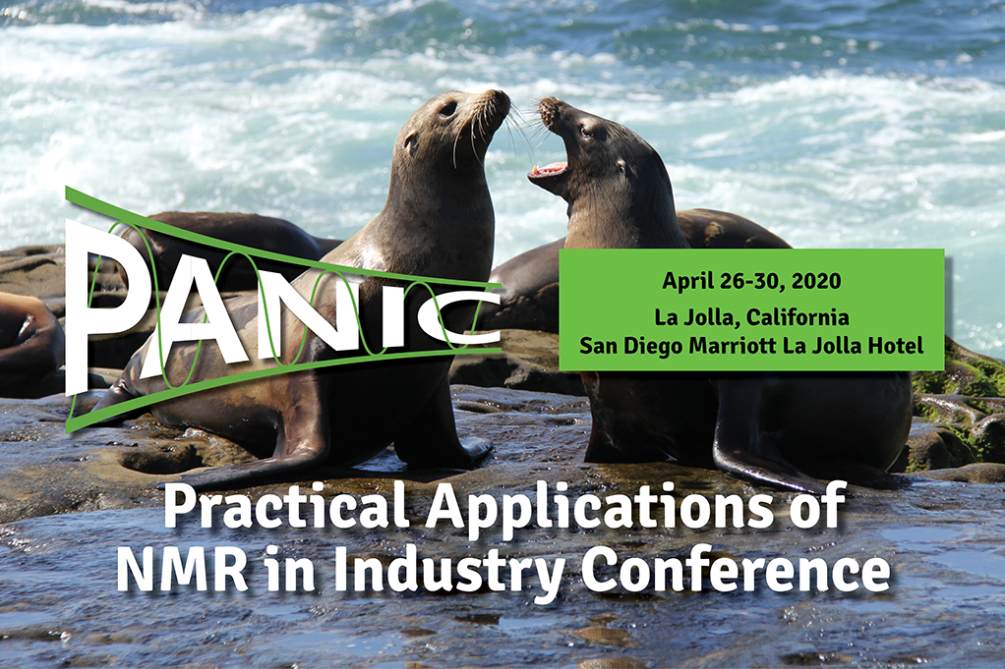

**Call for Abstracts for** [**PANIC 2020**](https://www.panicnmr.com/) **closes this Friday, September 20, 2019!**

-------

A reminder to all who do practical industry-focused NMR problem solving to [**submit an abstract**](https://ww2.eventrebels.com/er/CFP/OnlineSubmissionEMailLogin.jsp?CFPID=1026&Submit=Reset) ([www.panicnmr.com](http://www.panicnmr.com)) for consideration for oral or poster presentations at PANIC 2020.

This first open call for oral abstracts will close on **Friday, September 20, 2019.**

 We look forward to your contributions and seeing you at the [**San Diego Marriott La Jolla Hotel**](https://www.marriott.com/event-reservations/reservation-link.mi?id=1562000584349&key=GRP&app=resvlink) in the Spring!

John Marino (Chair, PANIC 2020) and Jim DeFelippis (Co-Chair, PANIC 2020)