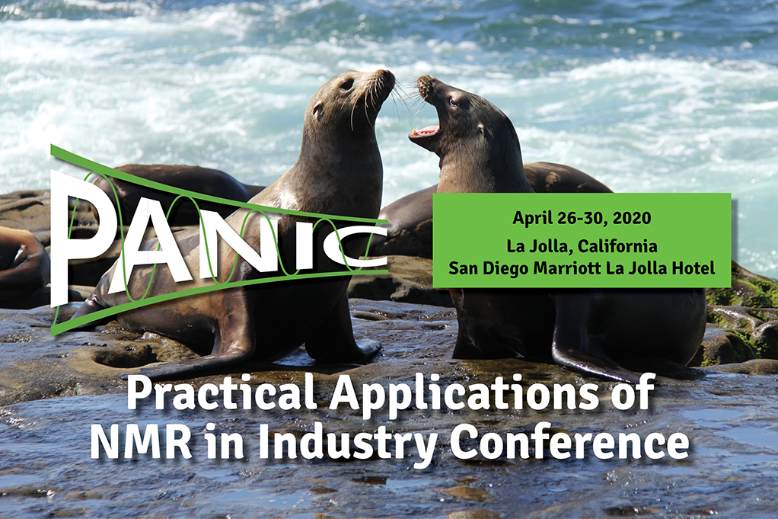

|  |
| --- |
| **Second Round Call for Abstracts** for [**PANIC 2020**](https://www.panicnmr.com/) is now open! |

 We encourage all who do practical industry-focused NMR problem solving to [**submit an abstract**](https://ww2.eventrebels.com/er/CFP/OnlineSubmissionEMailLogin.jsp?CFPID=1026&Submit=Reset) (https://www.panicnmr.com)for consideration for oral or poster presentations.

This second call for abstracts will close on **November 22, 2019.**

.

 We look forward to your contributions and seeing you in [**California**](https://www.marriott.com/event-reservations/reservation-link.mi?id=1562000584349&key=GRP&app=resvlink) in **April**!

John Marino (Chair, PANIC 2020) and Jim DeFelippis (Co-Chair, PANIC 2020)