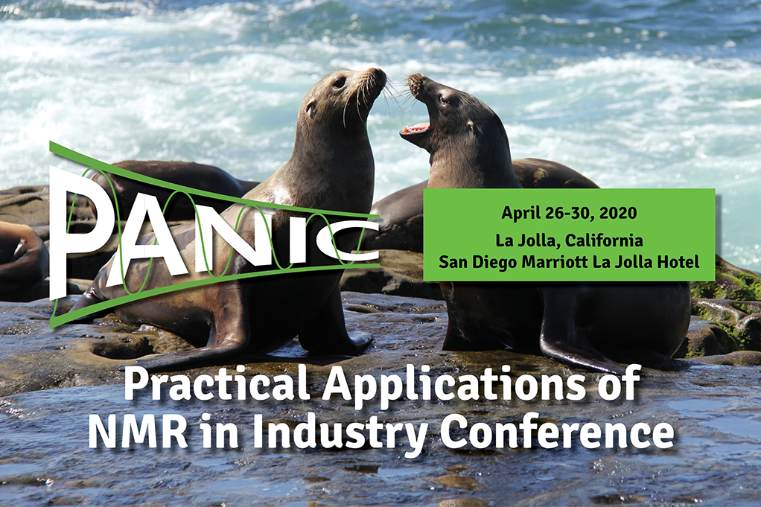

**CALL FOR LATE BREAKING POSTER ABSTRACTS:**  We encourage all who do practical industry-focused NMR problem solving to submit an abstract for consideration for a poster presentation.

-------

**Submit your abstract** at [**www.panicnmr.com**](http://www.panicnmr.com) for poster presentation at PANIC 2020.

**This last call for poster abstracts closes:** **Monday, February 3, 2020**

**Early Bird Registration ends: January 17, 2020**

 We look forward to your contributions and seeing you at the [**San Diego Marriott La Jolla Hotel**](https://www.marriott.com/event-reservations/reservation-link.mi?id=1562000584349&key=GRP&app=resvlink) in the Spring!

John Marino (Chair, PANIC 2020) and Jim DeFelippis (Co-Chair, PANIC 2020)